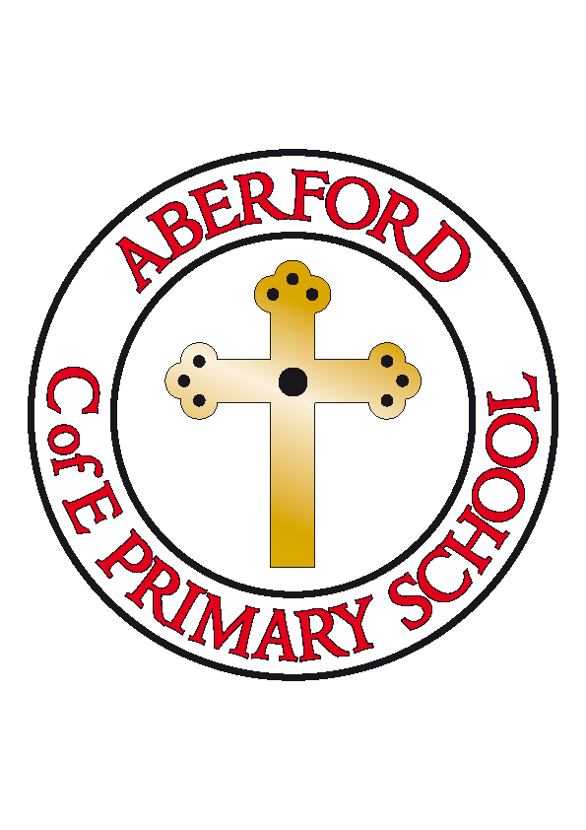
Aberford Church of England Primary School
School Lane, Aberford, Leeds, LS25 3BU
Tel: 0113 281 3302
Website: www.aberfordprimaryschool.co.uk
Headteacher – Philippa Boulding

17th March 2020
Dear Parents
As you are probably aware, the government’s guidance on the coronavirus was updated last night. I am writing to let you know the additional measures we are taking to help our school and wider community to remain safe and calm.
We are continuing to follow official guidance from the government and Leeds City Council. Therefore if your child has a new, continuous cough and/or a temperature, they should now stay at home for 14 days. If this is the case, advice is that all members of the household should self-isolate for 14 days. If your child is unwell, please report this as you would normally do by contacting the school office. If a child feels ill whilst at school we will contact you as normal.
From today, all non-essential visitors to school will be asked not to come in. This will mean that:
- Peripatetic music lessons with Roundhay Music and York Music will be postponed - please contact them directly if you have any questions regarding lessons paid for and not yet taken
- Castleford Tigers will not be visiting school to lead P.E.
- From today, after school clubs will be cancelled. Please collect all children from school at 3.15pm.
- Volunteers will not be working with us in school
We will also be postponing parents’ evening due to take place in the coming weeks. As always, if there is anything of particular importance you would like to discuss please contact school and we will endeavour to arrange a telephone conversation at a suitable time.
Thank you for your ongoing support and understanding at this uncertain time. We will continue to update you following any further advice.
Many thanks
Philippa Boulding

Headteacher

