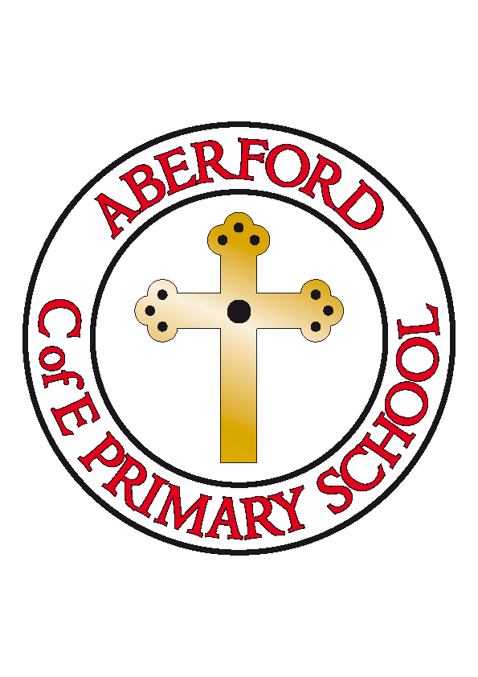
Aberford Church of England Primary School
School Lane, Aberford, Leeds, LS25 3BU
Tel: 0113 281 3302
Website: www.aberfordprimaryschool.co.uk
Headteacher – Philippa Boulding

16th March 2020
Dear Parents
As you are probably aware, the government’s guidance on the coronavirus has changed from the ‘contain’ phase to one of ‘delay’. I am writing to let you know what we are doing in light of this and also how we can work together to help our school and wider community to keep safe and calm.
We would like to reassure you that in school we are taking all of the necessary steps to protect our children and community, and are continuing to follow official guidance from the government and Leeds City Council.
If your child has any of the following symptoms they should remain at home for 7 days:
- a new, continuous cough and/or
- a temperature
If your child is unwell, please report this as you would normally do by contacting the school office. If a child feels ill whilst at school we will contact you as normal.
We continue to be vigilant in following guidance from Public Health England on hand washing and ensuring we all ‘catch it, kill it, bin it’.
We appreciate that some children may feel anxious. Please be assured that we are working hard to provide a calm and supportive environment for everyone at this time. We will continue to deliver information, advice and reassurance in an age appropriate way.
We will keep you advised of any further developments.
Thank you for your ongoing support and understanding.
Philippa Boulding

Headteacher

