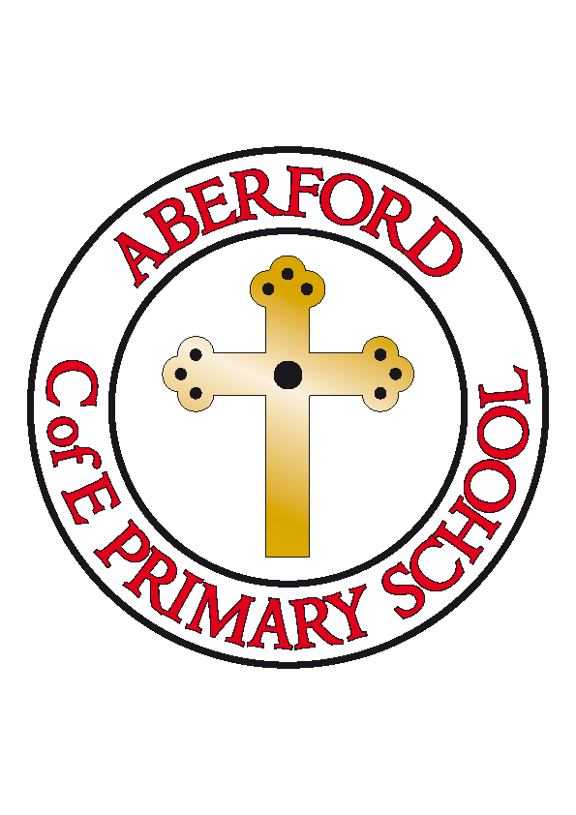
Aberford Church of England Primary School
School Lane, Aberford, Leeds, LS25 3BU
Tel: 0113 281 3302
Website: www.aberfordprimaryschool.co.uk
Headteacher – Philippa Boulding

THE WEEK AHEAD: Diary for the week beginning 9th October 2017

MONDAY | - Guitar Lessons with Roundhay Music (starting from 8.50am)  - KS1 After School Dance with Castleford Tigers
TUESDAY | - Brass Lessons with York Music  - KS1 Lunchtime Story Time with Mrs Briggs  - After School KS2 Football with Castleford Tigers
WEDNESDAY | - After School KS1 Gymnastics with Castleford Tigers
THURSDAY | - Class 3 Lunchtime Homework club  - KS2 After School Gymnastics with Castleford Tigers
FRIDAY | - Tuck Shop  - Woodwind lessons with York Music  - Class 4 Lunchtime Homework club  - KS2 After School Dance with Castleford Tigers

House Points (collected and reported by Ebony & Rubie T)
This week’s winners are Hazelwood with 539 house points

Aberford Achievements
Skye T for amazing work in PE
Herbie for his brilliant independent writing
Summer for her super attitude to learning all week
Charlotte for her fantastic attitude to learning
Millie L for her wonderful, positive attitude
Millie B for wonderfully imaginative and exciting writing relating to ‘Sky Hawk’
Ethan for a fantastic attitude and enthusiastic approach to all learning

Bronze awards for 50 house points were awarded to: Erica, Maddie J, Holly, Charlie N-K, Ruby H, Katie, Millie B, Evie D, Maddy C, Lavaya, Lizzy, Violet, Luca, Renita, Harrison, Kai, Ione, Herbie, Olive, Erin, Sam, Daisy, George H, Emmie & Kayla

P.T.A. News

P.T.A. meeting
Please note there has been a change to the date of the next meeting; it is now scheduled a day earlier for Wednesday 18th October, 7pm at the Arabian Horse.

Halloween party 2017/Bonfire night fireworks

Please 'save the date' for Saturday 28th October, 4-7pm at the Arabian Horse. Due to the close proximity in dates between both events we have decided to join the two together so there will be a firework display this year provided by Catherine & Steph of the Arabian Horse. Flyer's and ticket request forms will be distributed in book bags shortly; as always everyone is welcome so the event is open to friends and family to purchase tickets also.

Many thanks
Your P.T.A.

Sunbeams

Sunbeams playgroup is organising a family photo shoot on Sunday 15th October in the village hall. There are still 15 minute slots available at 11.30, 11.45 and 12.15 for £3 per session. The photographer offers a range of options for prints, or will provide all shots in the highest quality on a CD for £65. If you are interested in booking, or want further details please contact Kat Knox-Renshaw on 07766140393 or Janine Swales on 07808 590601

