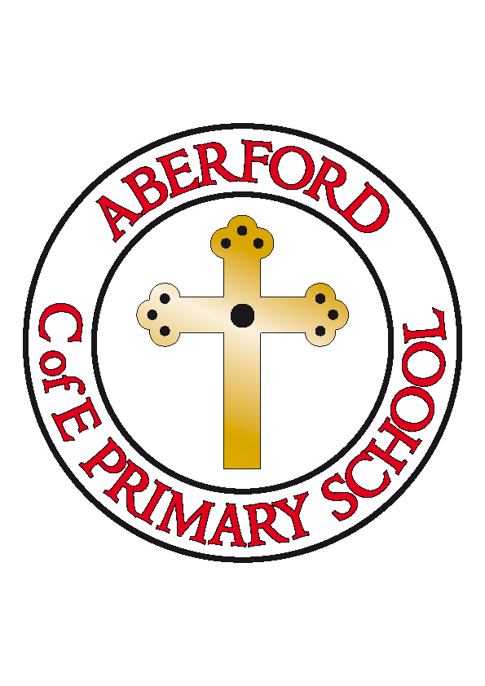
Aberford Church of England Primary School
School Lane, Aberford, Leeds, LS25 3BU
Tel: 0113 281 3302
Website: www.aberfordprimaryschool.co.uk
Headteacher – Philippa Boulding

THE WEEK AHEAD: Diary for the week beginning 19th June 2017

MONDAY | - Guitar Lessons with Roundhay Music (starting from 8.50am)  - Football Club
TUESDAY | - KS1 Dance with Castleford Tigers  - Diocesan Conference at York Racecourse
WEDNESDAY | - Brass Lessons with York Music
THURSDAY | - Tag Rugby with Castleford Tigers
FRIDAY | - Tuck Shop  - Woodwind lessons with York Music  - Non Uniform day in exchange for £1 or Chocolate to the same value
House Points (collected and reported by Jasmine, Evie S & Maddie J)

This week’s winners are Becca with 287 house points

Aberford Achievements

Lunchtime superstars Chloe D & Sam M
Olive for always being helpful in class
Bailey for his amazing effort in his phonics
Luca for his amazing performance during moon football
Caden for a fantastic attitude in rehearsals
Evie D for her kind and caring attitude
Rubie T for being so enthusiastic with Aladdin rehearsals
Anna for being so enthusiastic with Aladdin rehearsals

A Gold award for 150 house points was awarded to: Jack T
A Platinum award for 250 house points was awarded to: Kian
A Double Platinum award for 350 house points was awarded to: Luke
Diamond awards for 450 house points were awarded to: Ted & Isla

Gazebos
The Summer Gala is coming around quickly, we are hoping that you may be able to help. We are short of a few gazebos for the stalls at the gala and were hoping to be able to borrow some. If you have a gazebo that we are able to borrow please let the school office know. Thank you

P.T.A. News

Gala Queen & attendants
Congratulations to Ellie L who is this year's Gala Queen and attendants; Madeleine B (KS1) and Jasmine J (KS2).

Summer gala raffle
We have had a really good response from local businesses supporting our Summer Centenary gala and are able to raffle the following prizes: a voucher for Garforth Golf Club (worth £120), a family ticket for 'Bulletfest' music festival at The Crooked Billet public house, Saxton, Luxury food hamper, family pizza meal at the Arabian Horse public house, family day pass for the Summer Adventure at Stockeld Park, £25 meal for 2 voucher at Aagrah restaurant, Garforth, family day pass for Cannon Hall Farm and a bottle of Prosecco and chocolates courtesy of Sainsbury's, Colton. Tickets will be on sale next week priced at £1 each, you are more than welcome to purchase tickets on behalf of family or friends also.

Non-uniform day
To help raise money for the Chocolate tombola stall (as in previous years) the School are holding a non uniform day next Friday 23rd June. Please can all children that are participating bring £1 each into school.

Many thanks

Your P.T.A.

