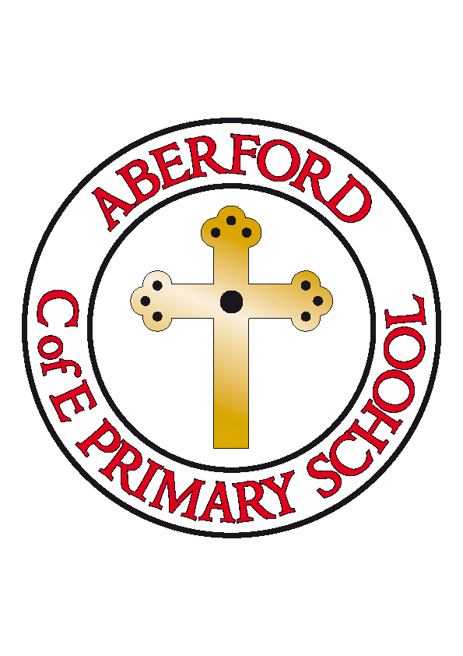
Aberford Church of England Primary School
School Lane, Aberford, Leeds, LS25 3BU
Tel: 0113 281 3302
Website: www.aberfordprimaryschool.co.uk
Headteacher – Philippa Boulding

THE WEEK AHEAD: Diary for the week beginning 9th March 2020

MONDAY | - KS2 Dance with Castleford Tigers – After school
TUESDAY | - KS2 Football with Castleford Tigers – After school  - Brass lessons with York Music
WEDNESDAY | - Guitar lessons with Roundhay Music  - KS1 Movement with Castleford Tigers – After school
THURSDAY | - KS2 Gymnastics with Castleford Tigers – After school
FRIDAY | - KS1 Dodge Ball with Castleford Tigers – After school
House Points (collected and reported by Bethany P, Evie N & Hayden)
This week’s winners are Hazelwood with 420 house points.

Aberford Achievements
Stan for working super hard in all areas of learning. He is kind to all his friends especially when they are sad
Phoebe for trying really hard with all of her work and for being so creative in English
Zac for trying really hard with his phonics and English work this week
Ione for always putting in 10% effort and setting a wonderful example to the class
Harrison for his hard work, dedication and amazing improvements on TTRS
Ava for shining in Maths this week
Alexander for superb leadership skills and wonderful presenting skills

Castleford Tigers Foundation Sports Awards
Amelia B For always being happy to take part in PE and never stops smiling
Isaac R For a fantastic improved attitude
Lottie for outstanding skills in PE and a good attitude
Max for fantastic improved attitude in PE
Megan for never giving in and outstanding improvement
Maddie C for a fantastic attitude and improvement in PE
Oliver B for excellent attitude and outstanding skills in PE
Hayden for a fantastic team work and always putting in 100% effort

Gold awards for 200 House Points were awarded to James D, Ruby Wi, Jack M, Elliot, Freya H and Zac
Super Gold awards for 300 House Points were awarded to Mikey, Sam, Lizzy and Violet C
Platinum awards for 400 House Points were awarded to Anna and Maddy C

The Big Dance Off
Congratulations to our KS2 children who took part in The Big Dance Off yesterday. After a tough competition they placed 6th out of 20 schools with a score of 186 out of 200.

