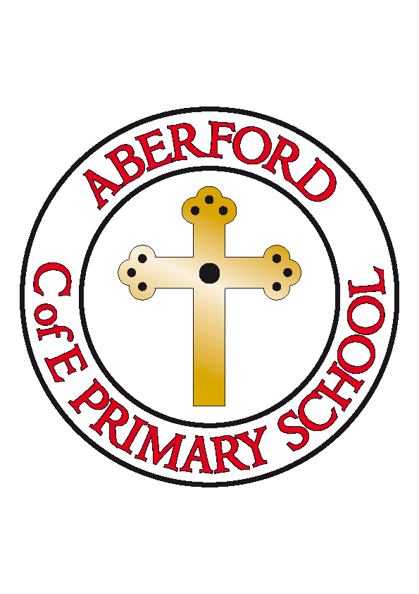
Aberford Church of England Primary School
School Lane, Aberford, Leeds, LS25 3BU
Tel: 0113 281 3302
Website: www.aberfordprimaryschool.co.uk
Headteacher – Philippa Boulding

THE WEEK AHEAD: Diary for the week beginning 17th December 2018
MONDAY | - KS1 Nativity 1.45pm in the school hall
TUESDAY | - KS1 Nativity 1.45pm in the school hall  - Brass Lessons with York Music
WEDNESDAY | - Road Safety Pantomime
THURSDAY | - Christmas Jumper Day and Christmas Dinner
FRIDAY | - Tuck Shop
House Points (collected and reported by Poppy & Chloe D)
Last week’s winners were Becca with 172 house points
This week’s winners are Parlington with 162 house points

Aberford Achievements
Livvy for fantastic listening
Evora for excellent effort in Maths
Jack M for remembering all his cues in our Nativity
Keean for his fantastic attitude towards learning his timetables
Renita for her fantastic attitude to all aspects of learning
Poppy for consistently producing vivid writing which never fail to entice the reader!
Tommy-Lee for starting to add more detailed descriptions in written work

Silver awards for 100 House Points were awarded to: James D, Jack M, Alexander and Ava

A Message on behalf of St Ricarius Church
Please note the last minute change of date for the Carols on the Green as per the text sent by school on the 12th December. This will now take place on Thursday the 20th December at 6.00pm.
The Crib service will take place on Christmas Eve at 4.30pm and will include a no-rehearsal Nativity. Please feel free to come along dressed as someone from the Christmas story. You will be able to take part in acting out the Nativity story – no rehearsal necessary!
There will be a service at St Ricarius Church at 11.00am on Christmas day led by the Bishop of Selby Abbey. Everyone is welcome and we look forward to seeing you.

