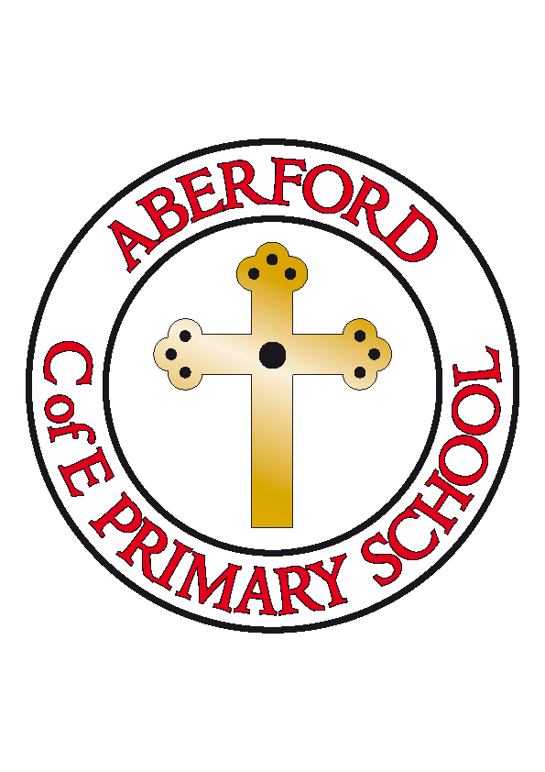
Aberford Church of England Primary School
School Lane, Aberford, Leeds, LS25 3BU
Tel: 0113 281 3302
Website: www.aberfordprimaryschool.co.uk
Headteacher – Philippa Boulding

THE WEEK AHEAD: Diary for the week beginning 16th December 2019

MONDAY | - Class 1 & Class 2 Nativity performance 2pm
TUESDAY | - Class 1 & Class 2 Nativity performance 2pm  - Brass lessons with York Music
WEDNESDAY
THURSDAY | - Flu immunisations  - Christmas Jumper Day and Christmas Dinner Day
FRIDAY
House Points (collected and reported by Evie N & Olivia)
This week’s winners are Parlington with 346 house points

Aberford Achievements
Katy for a fantastic attitude to learning and trying very hard with her reading and phonics
Connie for always doing the right thing and for always giving 100% effort
Phoebe for trying to be quicker with all of her work
Erin for writing a wonderful, thoughtful poem on freedom
Violet C for being a kind, considerate and thoughtful member of Class 3 who is always the first to help others
Kara for always putting 100% effort into everything she does
Kaitlyn for a wonderful effort and attitude to learning in all subjects

Bronze awards for 50 House Points were awarded to Scarlett and Lily
Silver awards for 100 House Points were awarded to Natey, Megan, James D, Anna and Ruby Wa
A Gold award for 200 House Points was awarded to Chloe S
Super Gold awards for 300 House Points were awarded to Emily and Freya G

PTA NEWS
Thank-you to everyone who joined us at the Christmas party last weekend, it was a great night and we managed to raise just under £700!

Don’t forget, next week is your last chance to get a PTA school calendar if you want one. This year the calendar features some of the children’s artwork as well as the usual individual and group photos of all the children.They are available from the school office all next week at £4 each or 3 for £10. There is only a limited number left though so be quick if you want one!

We would just like to say thank-you to everyone who has helped and supported the PTA this year, we have had a great year and we look forward to organising more fun events in the New Year.

We hope you all enjoy the festive break.
Happy Christmas!
Jenny, Rosh and Lisa

