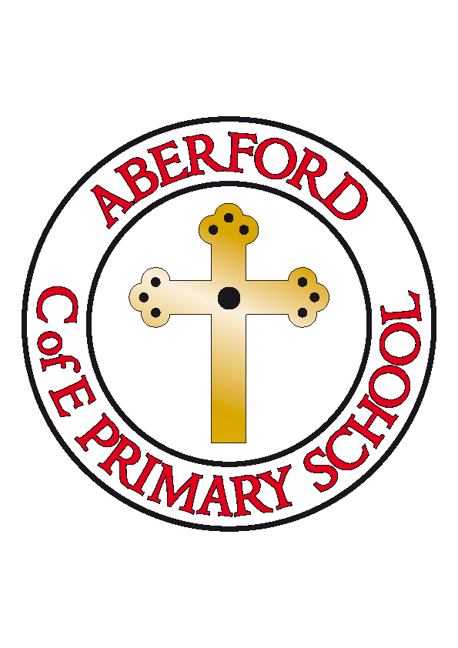
Aberford Church of England Primary School
School Lane, Aberford, Leeds, LS25 3BU
Tel: 0113 281 3302
Website: www.aberfordprimaryschool.co.uk
Headteacher – Philippa Boulding

THE WEEK AHEAD: Diary for the week beginning 26th June 2017

MONDAY | - Guitar Lessons with Roundhay Music (starting from 8.50am)  - Football Club
TUESDAY | - KS1 Dance with Castleford Tigers
WEDNESDAY | - Brass Lessons with York Music
THURSDAY | - Tag Rugby with Castleford Tigers
FRIDAY | - Tuck Shop  - Woodwind lessons with York Music
House Points (collected and reported by Jasmine, Evie S & Maddie J)

This week’s winners are Hazelwood with 108 house points

Aberford Achievements

Congratulations to the whole school for a successful and enjoyable sports day
Max for fantastic singing
Tilly & Liam for working hard with their fractions

A Gold award for 150 house points was awarded to: David
Super Gold awards for 200 house points were awarded to: Harrison SJ & Harry
A Platinum award for 350 house points was awarded to: Chloe D
A Double Platinum award for 350 house points was awarded to: Isobel

P.T.A. News

Summer gala donations
We're still collecting for the Tombola stall and 'Find the bottle'; all donations will be greatly received.

We are also asking for donations for the cake stall, please either bring them into school next Friday (30th June) or to the Gala on the day itself (Saturday 1st July).

Many thanks
Your P.T.A.

