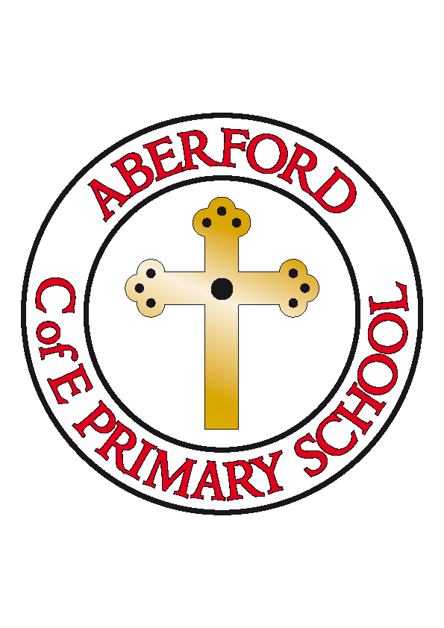
Aberford Church of England Primary School
School Lane, Aberford, Leeds, LS25 3BU
Tel: 0113 281 3302
Website: www.aberfordprimaryschool.co.uk
Headteacher – Philippa Boulding

THE WEEK AHEAD: Diary for the week beginning 8th May 2017
SATS TEST WEEK
SATS BREAKFAST MONDAY - THURSDAY FROM 8.10AM ALL YEAR 6 WELCOME

MONDAY | - Football Club
TUESDAY | - KS1 Dance with Castleford Tigers
WEDNESDAY | - Film Club
THURSDAY | - Tag Rugby with Castleford Tigers
FRIDAY | - Tuck Shop

House Points (collected and reported by Alfie & Ellie)
This week’s winners are Lotherton with 226 house points

Aberford Achievements
Kayla Ali for fantastic writing in Literacy
Renita Ali for her amazing handwriting in her Timone and Pumba story
Caleb Parsons for his brilliant ideas about sacrifice in the story of the Monkey King
Evie Durkin for always having lovely manners
Harry Hallatt for amazing contributions in Collective Worship
Anna Horsfield for producing such creative homework tasks
Lewis Cass for a wonderful attitude to learning

A Silver award for 100 house points was awarded to: David Wood
Gold awards for 150 house points were awarded to: Harry, Jessica, Tommy-Lee, Caden, Logan, Sebastian, Jack, Kaitlyn, Alexa, Freya H, Freya G, Renita and Maddy C
Super Gold awards for 200 house points were awarded to: Summer, Lavaya, Liam & Zac
Platinum awards for 250 house points were awarded to: William S, Chloe S & Charlie NK
A Double Platinum award for 350 house points was awarded to Anna

Year 6 SATs
As we rapidly approach the National testing week, we would like to wish our 12 Year 6 children the very best of luck in their SATs next week. They have worked incredibly hard, have remained focused and have been a real credit throughout the year. We are extremely proud of you all!

Welcome back
We would like to welcome back Mr Barritt after his paternity leave and congratulate him and Mrs Barritt on the birth of their new son ‘Noah’

