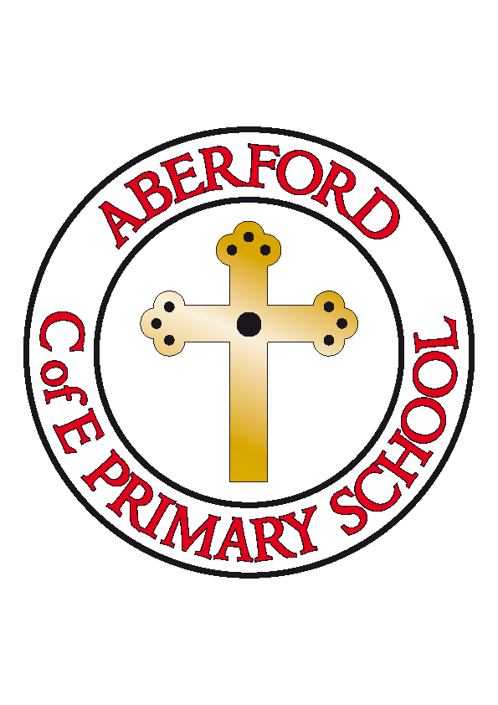
Aberford Church of England Primary School
School Lane, Aberford, Leeds, LS25 3BU
Tel: 0113 281 3302
Website: www.aberfordprimaryschool.co.uk
Headteacher – Philippa Boulding

THE WEEK AHEAD: Diary for the week beginning 1st May 2017

MONDAY | - Bank Holiday
TUESDAY | - KS1 Dance with Castleford Tigers
WEDNESDAY | - Brass Lessons with York Music  - Film Club
THURSDAY | - Tag Rugby with Castleford Tigers
FRIDAY | - Tuck Shop  - Woodwind lessons with York Music

House Points (collected and reported by Luke & Ted)

This week’s winners are Lotherton with 174 house points

Aberford Achievements

Isabella for her amazing princess story
Nathan for a super comparison between a fireman in 1666 and present day
Millie P for a fantastic effort in all her work this week
Beth P for being a superstar in maths
Alexander S for being enthusiastic and helpful in science
Luke for fantastic maths work and a super attitude
Isla for a super attitude to learning putting 100% effort in to everything

Silver awards for 100 house points were awarded to: Sebastian, Alexa, Kaitlyn, George, Caleb, Joshua & Tommy-Lee
Gold awards for 150 house points were awarded to: Leighton, Lizzy
Super Gold awards for 200 house points were awarded to: Chloe D & Emily

