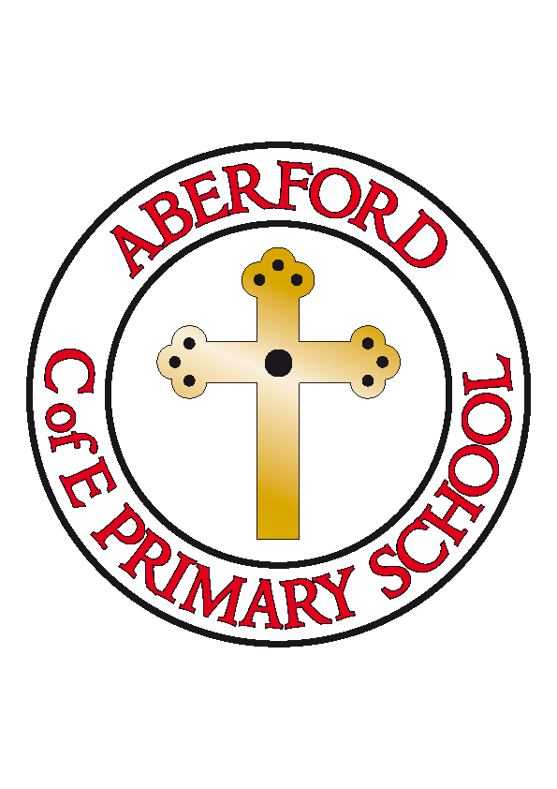
Aberford Church of England Primary School
School Lane, Aberford, Leeds, LS25 3BU
Tel: 0113 281 3302
Website: www.aberfordprimaryschool.co.uk
Headteacher – Philippa Boulding

THE WEEK AHEAD: Diary for the week beginning 24th April 2017

MONDAY | - Guitar Lessons with Roundhay Music (starting from 8.50am)  - Football Club
TUESDAY | - KS1 Dance with Castleford Tigers
WEDNESDAY | - Brass Lessons with York Music  - Film Club
THURSDAY | - Tag Rugby with Castleford Tigers
FRIDAY | - Tuck Shop  - Woodwind lessons with York Music

House Points (collected and reported by Alfie & Ellie)
This week’s winners are Lotherton with 232 house points

Aberford Achievements
George for his brilliant home learning. We love the Solar System you have made!
Alexa for a super attitude to all her learning this week
Logan for being really focused in English this week and producing super writing
Tilly for always having an excellent attitude towards learning
Maddie SJ for her superb work on co-ordinates
Lucy for a super setting description packed with imagery and thoughtful vocabulary
Abigail for a super setting description packed with imagery and thoughtful vocabulary

A Super Gold award for 200 house points was awarded to: Kian
A Platinum award for 250 house points was awarded to: Ethan

Dinner Money
The total cost for the half term until Friday 26th May will be:

Year 3 & 4 £57.40 (28 days @ £2.05 per day)
Years 5 & 6 £58.80 (28 days @ £2.10 per day)

P.T.A. News

Summer Gala

Please note, the date of this year's Summer Gala has been changed to Saturday 1st July (which was the original date). This is because there is a Cubs and Scouts camp being held the following weekend at Bramham Park which a number of our pupils will be attending. Apologies for any inconvenience caused.

Easter event

Unfortunately the weather wasn't on our side on Easter Sunday but thanks to all of you who came out to support us. We managed to raise £120 (profit) however we have over £300 worth of stock to carry forward to the Summer Gala. With grateful thanks to everyone who volunteered and helped us out.

The winner of the giant Easter bunny toy was Mrs Slater (winning ticket no. 61, drawn by Steph of the Arabian Horse) and the Easter quiz was won by Kaitlyn & Erin and family with a score of 35/50. The prize was a family pizza bundle at the Arab (4 pizzas, 4 fries and garlic bread to share). Thanks to all who entered.

Easyfundraising

Since last October, 37 members have together raised over £470 which will go directly to P.T.A. funds. This is a fantastic way to help raise money and it's never too late to join so, if you're thinking about booking this year's Summer holiday on line, please consider going through Easyfundraising.org.uk (cause name: Aberford Primary PTA - Leeds). Thank you.

Your P.T.A.

A message from LCC - Roundhay Park Primary Free School

A consultation is now live asking the city to comment on site options for the proposed Roundhay Park Primary free school.
A free school bid from the Roundhay Park Primary School Trust has been approved by the Secretary of State for Education to provide additional school places in the Roundhay area. There are four sites which have the greatest potential to host the school; however there are issues with each of them. One of these sites is on a part of Roundhay Park so Leeds City Council feels it is right that the whole city has a say on whether it should be further considered for this purpose.

Here is a link to more information about the consultation, including details about how to submit comments by 28 April:http://www.leeds.gov.uk/residents/Pages/Currentschoolsconsultation.aspx.

