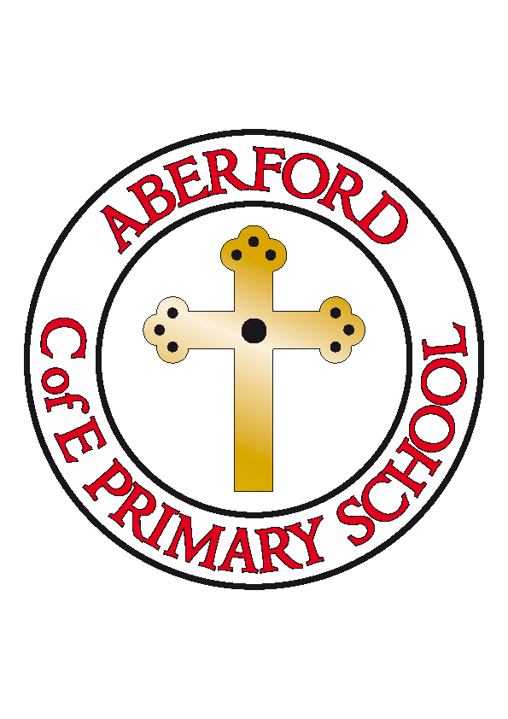
Aberford Church of England Primary School
School Lane, Aberford, Leeds, LS25 3BU
Tel: 0113 281 3302
Website: www.aberfordprimaryschool.co.uk
Headteacher – Philippa Boulding

THE WEEK AHEAD: Diary for the week beginning 20th March 2017

MONDAY | - Guitar Lessons with Roundhay Music (starting from 8.50am)  - Mandarin Club (lunchtime)  - Football
TUESDAY | - KS1 Dance with Castleford Tigers  - Choir (lunchtime)
WEDNESDAY | - Events Committee/School Council (lunchtime)  - Brass Lessons with York Music  - Film Club
THURSDAY | - Tag Rugby with Castleford Tigers
FRIDAY | - Tuck Shop  - Woodwind lessons with York Music  - Wear a red nose day item (alongside school uniform) for Comic Relief

House Points (collected and reported by Alfie & Ellie)
This week’s winners are Becca with 173 house points

Aberford Achievements
Millie SJ for brilliant music work with Mrs Russell
Luca for adding two digit numbers in maths
Sebastian for using amazing similes in his desert island recount
Evie H for creating a fantastic story map
Harry for his great attitude this week
Alexander L for contributions to learning in Science
Alfie for his excellent scientific report on levers

A Gold award for 150 house points was awarded to: Zac
Super Gold awards for 200 house points were awarded to: Chloe S, Tilly, Evie D, Bethany S, Billy, Alexander S, Evie S, Ellie and Ruby H
Platinum awards for 250 house points were awarded to: Skye and Isabella L
A Double Platinum award for 350 house points was awarded to: Jasmine

A message from The Revd. Martin Otter
On Good Friday, Friday 14th April, All Saints Church, Sherburn in Elmet, will be having a ‘Messy Church’ to help us all remember the true story of Easter. It is aimed at pre-school and primary school aged children, and along with a simple story and message there will be 10 or so craft based activities for the children to take part in during the morning. It starts at 9.30 and finishes at 11.00 although you are free to come for as long or as short a time as you wish, refreshments served though out. Please contact Revd. Martin Otter, 07842106044, if you would like some more information. There is a best decorated egg (of the chicken variety) competition, and in the past there have been over 30 children so you won’t be on your own!

